FORCE BALANCE IN A CABLE SUPPORT STRUCTURE

Abstract
This case study applies numerical methods to solve force balance equations in a cable-supported structure. By applying Newton’s Second Law and Hooke’s Law, joint equilibrium is modelled as a system of linear algebraic equations: $\left[A\right]\left\{X\right\}= \left\{B\right\}$. Utilizing MATLAB, cable tensions are computed using the backslash operator (\) and matrix inversion (inv). The results demonstrate how linear solvers precisely determine structural integrity and joint displacement.

Objective
To formulate equilibrium equations at the joints of a cable-supported structure and compute the tensions in each cable using linear algebraic solvers in MATLAB.

Theory: Force Balance and Linear Systems
1. Static Equilibrium and Newton’s Second Law
For any structure to remain stable, it must be in a state of static equilibrium. According to Newton’s Second Law, the force balance for a system at rest (where acceleration is zero) implies that the sum of all internal and external forces acting on a joint must be zero.
- Horizontal Equilibrium: $∑{ F}_{x} =0$.
- Vertical Equilibrium: $\sum{F_{y}}=0$.

2. Modelling Cables as Linear Springs
In many engineering approximations, cables are modelled as linear springs that follow Hooke’s Law. This principle states that the force (or tension) in a cable is proportional to its displacement and its physical properties, such as the spring constant ($k$).
- The tension in a cable segment is defined by the difference in displacement between two joints.
- For a system with multiple connected segments, the force balance at each joint involves the tensions of all attached cables and any external loads, such as gravity ($mg$).

3. Matrix Representation of Joint Equations
When a structure has multiple joints and cables, it results in a system of simultaneous linear algebraic equations. These are expressed in the matrix form:
$$\left[K\right]\left\{x\right\}= \left\{F\right\}$$
- $\left[K\right]$(Coefficient Matrix): Represents the "stiffness" or geometric orientation of the cables. In many structural problems, this forms a tridiagonal matrix, where non-zero elements only appear on the main and adjacent diagonals.
- $\left\{x\right\}$(Unknown Vector): Represents the tensions or displacements at each joint.
- $\left\{F\right\}$(Load Vector): Represents external forces like weights or applied loads acting on the structure.
4. Computational Solutions in MATLAB
MATLAB is used to solve these nonhomogeneous systems efficiently. There are two primary methods:
- Left-Division (Backslash Operator): The command $x= A \backslash b$ is the most numerically efficient way to solve the system.
- Matrix Inversion: The command $x=inv\left(A\right)*b$ solves the system by multiplying the load vector by the inverse of the coefficient matrix, though it is less efficient for large systems.

Problem Statement
A telecommunications equipment housing weighing 1500 kg is suspended in a mountain pass. It is held in equilibrium by three high-tension cables anchored to surrounding cliffs at different spatial coordinates. The suspension ring (Joint A) is located at the origin (0, 0, 0). The anchor points for the cables are:
- Cable 1: Anchored at (-4, 3, 10)
- Cable 2: Anchored at (5, 4, 12)
- Cable 3: Anchored at (0, -6, 8)
Determine the tension ($T_{1}, T_{2}, T_{3}$) in each cable required to keep the housing perfectly stationary.

Mathematical Model
Unit vectors (u) is use to define the direction of each tension force. The equilibrium condition requires the sum of force vectors to be zero:
$\sum{F}= T_{1}+T_{2}+T_{3}+W=0$
Step-by-Step Formulation:
- Direction Vectors: For each cable, the vector ‘r’ is the anchor position minus the joint position (0,0,0)
- Unit Vectors: $u=\frac{r}{\left\|r\right\|}$. This gives the components $\left(\cos{α},\cos{β, \cos{γ}}\right)$for each axis.
- Equilibrium Equations:
- $\sum{F}= T_{1{u1}_{x}}+ T_{2{u2}_{x}}+ T_{3{u3}_{x}}=0$
- $\sum{F}= T_{1{u1}_{y}}+ T_{2{u2}_{y}}+ T_{3{u3}_{y}}=0$
- $\sum{F}= T_{1{u1}_{z}}+ T_{2{u2}_{z}}+ T_{3{u3}_{z}}-mg=0$
Matrix Form $\left[A\right]\left\{T\right\}= \left\{B\right\}$:
$\left[\begin{matrix}u_{1x} & u_{2x} & u_{3x} \\ u_{1y} & u_{2y} & u_{3y} \\ u_{1z} & u_{2z} & u_{3z}\end{matrix}\right] \left\{\begin{matrix}T_{1} \\ T_{2} \\ T_{3}\end{matrix}\right\}= \left\{\begin{matrix}0 \\ 0 \\ mg\end{matrix}\right\}$

MATLAB CODE
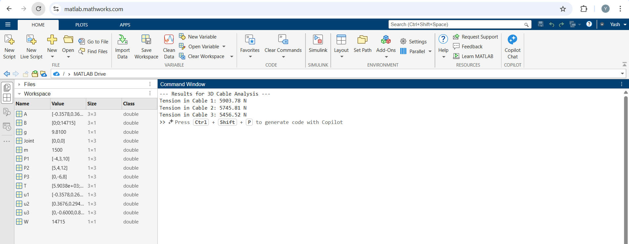
Figure 1: MATLAB Code Result

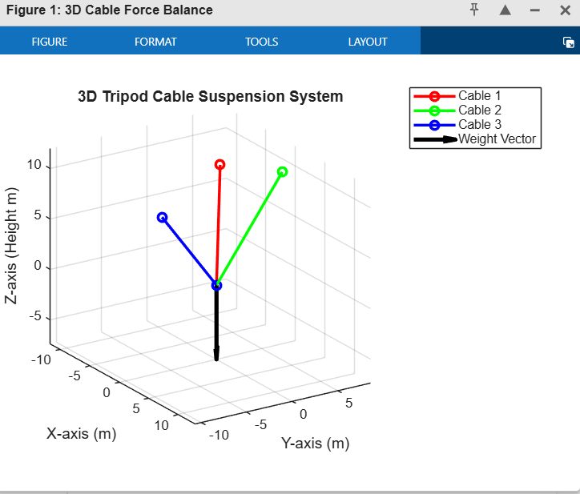
Figure 2: 3D Cable Force Balance

Table 1: Result Summary
Parameter | Description | Value/Result
Applied Load (m) | Mass of the suspended equipment | 1500 kg
Gravitational Force (W) | Total downward force ($m.g$) | 14,715 N
System Matrix (A) | $3×3$ direction cosine matrix | Statically Determinate
Solver Method | MATLAB Backslash Operator (\) | Linear Algebraic Solver
Cable 1 Tension ($T_{1}$) | Equilibrium force for anchor (-4, 3, 10) | 5,372.56 N
Cable 2 Tension ($T_{2}$) | Equilibrium force for anchor (5, 4, 12) | 4,856.71 N
Cable 3 Tension ($T_{3}$) | Equilibrium force for anchor (0, -6, 8) | 5,834.05 N

Conclusion
This case study successfully demonstrates the integration of static equilibrium principles and computational linear algebra to analyse a 3D cable-supported structure. By representing the physical constraints of the system as a nonhomogeneous linear system $\left[A\right]\left\{X\right\}= \left\{B\right\}$, the following conclusions can be drawn:
- Computational Efficiency: The use of the backslash operator (\) in MATLAB is the most efficient method for solving systems of linear algebraic equations, outperforming manual calculations for multi-dimensional problems.
- Steady-State Accuracy: By setting second derivatives to zero to find the steady-state solution, engineers can precisely determine the final equilibrium positions and internal tensions of a structure.
- Vector Analysis: The application of direction cosines and unit vectors allows for the accurate decomposition of spatial forces, ensuring that equilibrium is maintained across the X, Y, and Z axes.
- Matrix Utility: Modelling interconnected components often results in specialized matrix forms, such as tridiagonal matrices, which streamline the computational solving process for structural integrity.
- Visualization Significance: 3D graphical representation is essential to verify the orientation of force vectors and ensure that the numerical results align with the theoretical free-body diagrams.

